Tools Used in CI Pipeline
- Whispers:

Whispers is a static code analysis tool designed for parsing various common data formats in search of hardcoded credentials and dangerous functions.

Identify hardcoded secrets in static structured text.

Whispers is intended to be a structured text parser, not a code parser.

Detects
- Passwords
- API tokens
- AWS keys
- Private keys
- Hashed credentials
- Authentication tokens
- Dangerous functions
- Sensitive files

In Pipeline we use the following command, were github.workspace is the repo name used.

- name: Run scanner for the repository
continue-on-error: true
run: |
whispers ${{ github.workspace }} > whispers.txt
.github/workflows/scripts/whispers.sh

Below is the whispers.sh file.
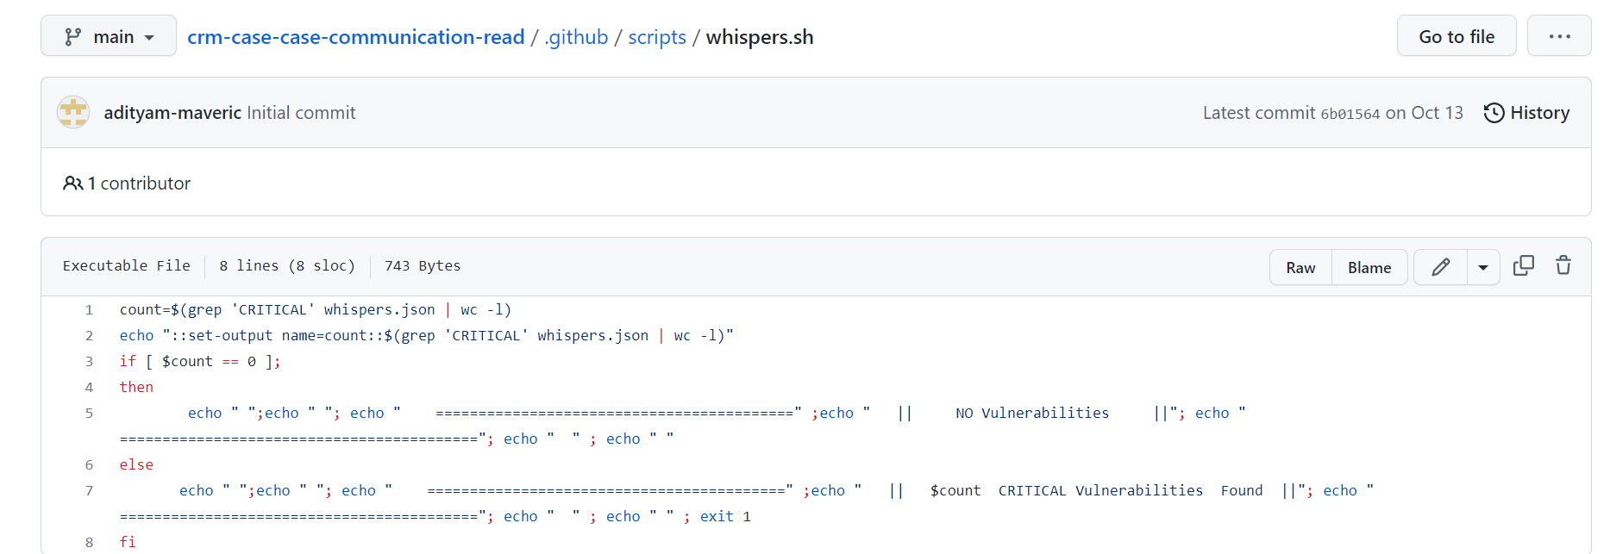

- Maven:

Maven is chiefly used for Java-based projects, helping to download dependencies, which refers to the libraries or JAR files. The tool helps get the right JAR files for each project as there may be different versions of separate packages.

After Maven, downloading dependencies doesn’t require visiting the official websites of different software. You can visit mvnrepository to find libraries in different languages. The tool also helps to create the right project structure in struts, servlets, etc., which is essential for execution.

- name: Maven Build
run: ${{inputs.MAVEN_HOME}}/bin/mvn clean package
working-directory: ${{inputs.BUILD_PATH}}

- SonarQube Scan:

SonarQube is a Code Quality Assurance tool that collects and analyzes source code, and provides reports for the code quality of the project. It combines static and dynamic analysis tools and enables quality to be measured continually over time.

- name: SonarQube Scan
uses: unobankasia/sonarqube-action-1@v1.2.1
with:
host: ${{ secrets.SONARQUBE_HOST }}
login: ${{ secrets.SONARQUBE_TOKEN }}
projectBaseDir: ./
projectKey: ${{inputs.MICROSERVICES}}
binaries: target/classes
exclusions: ${{inputs.EXCLUDED_CLASS}}

- name: SonarQube Quality Gate check
continue-on-error: true
uses: sonarsource/sonarqube-quality-gate-action@master
timeout-minutes: 5
env:
SONAR_TOKEN: ${{ secrets.SONARQUBE_TOKEN }}
with:
scanMetadataReportFile: .scannerwork/report-task.txt

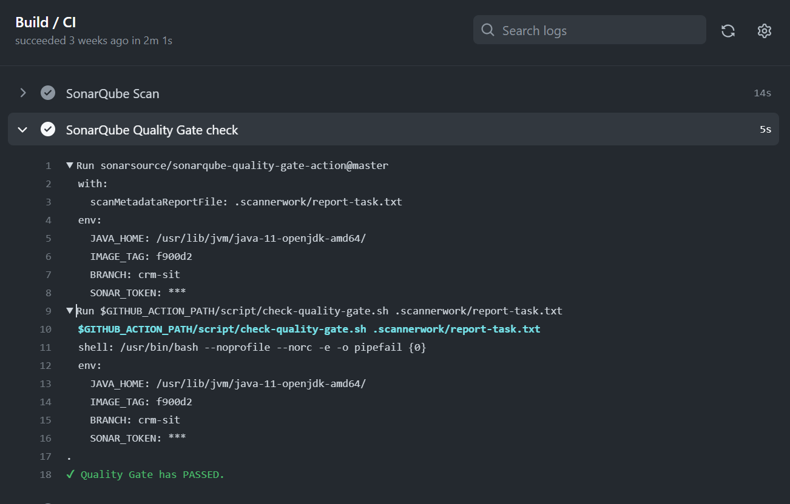

- Docker:

Docker is an open-source centralized platform designed to create, deploy, and run applications. Docker uses container on the host's operating system to run applications. It allows applications to use the same Linux kernel as a system on the host computer, rather than creating a whole virtual operating system. Containers ensure that our application works in any environment like development, test, or production.

- name: Docker Build
run: docker build -t ${{inputs.MICROSERVICES}}:$IMAGE_TAG .

- Trivy Image:

Trivy is a Simple and Comprehensive Vulnerability Scanner for Containers, Suitable for CI. A software vulnerability is a glitch, flaw, or weakness present in the software or in an Operating System.

It detects vulnerabilities of OS packages (Alpine, RHEL, CentOS, etc.) and application dependencies (Bundler, Composer, npm, yarn etc.).

Detect comprehensive vulnerabilities
OS packages (Alpine, Red Hat Universal Base Image, Red Hat Enterprise Linux, CentOS, Debian, Ubuntu, Amazon Linux and Distroless)
Application dependencies (Bundler, Composer, Pipenv, Poetry, npm, yarn and Cargo)

Specify only an image name

- name: Vulnerabilities
env:
ECR_URL: ${{ steps.login-ecr.outputs.registry }}
run: trivy image $ECR_URL/${{inputs.MICROSERVICES}}:$IMAGE_TAG

After giving the env and image name, trivy wil check for the vulnerabilities in the image as low, medium, high and critical as shown below.

